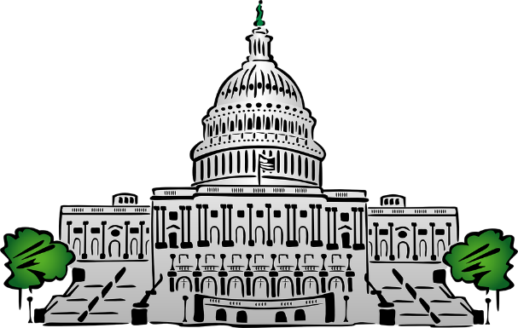
House Impact Aid Coalition
118th Congress

Co-Chairs
Courtney, Joseph (D-CT)
Newhouse, Dan (R-WA)

Steering Committee
Pallone, Frank (D-NJ)
Scott, Bobby (D-VA)
Smith, Chris (R-NJ)

General Membership
Amodei, Mark (R-NV)
Armstrong, Kelly (R-ND)
Bacon, Don (R-NE)
Bishop, Sanford (D-GA)
Bost, Mike (R-IL)
Brownley, Julia (D-CA)
Bucshon, Larry (R-IN)
Burgess, Michael (R-TX)
Calvert, Ken (R-CA)
Carson, André (D-IN)
Carter, Buddy (R-GA)
Carter, John (R-TX)
Castro, Joaquin (D-TX)
Cicilline, David (D-RI)
Clyburn, James (D-SC)
Cole, Tom (R-OK)
Connolly, Gerald (D-VA)
Cuellar, Henry (D-TX)
Davis, Danny (D-IL)

DelBene, Suzan (D-WA)
Doggett, Lloyd (D-TX)
Fischbach, Michelle (R-MN)
Foster, Bill (D-IL)
Gonzales, Tony (R-TX)
Gosar, Paul (R-AZ)
Gottheimer, Josh (D-NJ)
Granger, Kay (R-TX)
Grijalva, Raúl (D-AZ)
Guthrie, Brett (R-KY)
Guest, Michael (R-MS)
Hoyer, Steny (D-MD)
Huffman, Jared (D-CA)
Johnson, Dusty (R-SD)
Kilmer, Derek (D-WA)
Kim, Andy (D-NJ)
Lamborn, Doug (R-CO)
Larsen, Rick (D-WA)
Lee, Barbara (D-CA)
Lucas, Frank (R-OK)

McCarthy, Kevin (R-CA) McMorris Rodgers, Cathy (R-WA)
Norcross, Donald (D-NJ)
Norton, Eleanor (D-DC)
Obernolte, Jay (R-CA)
Payne Jr., Donald (D-NJ)
Pascrell, William (D-NJ)
Peters, Scott (D-CA)
Rogers, Michael (R-AL)
Sarbanes, John (D-MD)
Schneider, Brad (D-IL)
Schrier, Kim (D-WA)
Simpson, Mike (R-ID)
Smith, Adam (D-WA)
Smith, Jason (R-MO)
Stefanik, Elise (R-NY)
Tenney, Claudia (R-NY)
Thompson, Mike (D-CA)
Turner, Mike (R-OH)
Williams, Roger (R-TX)
Wittman, Robert (R-V)

